To,
The Associate Dean Academic UG
Academic Section
IIT Patna

Through Proper Channel:
1. BTP Supervisor
2. Faculty Advisor
3. Head of Department (CSE)

Subject: Request for issuance of NOC for 6-month Internship at Tower Research Capital from January 2026 till June 2026

Respected Sir,
I, Erum Meraj (Roll Number: 2201CS24), 4th Year Student of B.Tech in Computer Science and Engineering, am writing to formally request your approval to pursue a 6-month internship at Tower Research Capital (Location: Gurgaon, Mode: In-Person) from January 2026 to June 2026, during my 8th semester, and request the issuance of a No Objection Certificate (NOC) for the same.
Under Office Order Ref No. IITP/Acad/DR/2024/271, Option 2, dated 18.11.2024, I propose undertaking 3 Department Electives my 8th semester, by the respective faculties at IIT Patna through hybrid mode, as approved by my Faculty Advisor and HOD, to fulfil the semester credit requirements. I hereby assure you that I will complete all assignments diligently and will be physically present for the mid-semester and end-semester examinations of all enrolled courses, as per the academic regulations and prescribed schedule. I am confident that the online materials provided by the faculty will enable me to independently grasp the subjects in depth and excel in the examinations. I kindly seek your permission to access lab manuals, course presentation slides, and online resources for this course to stay on track with lab work while off-campus.
In consultation with my BTP Supervisor, I will maintain regular communication and ensure consistent progress on my Individual Project (BTP) during the internship period. I will be present on campus for both the mid-semester and end-semester offline BTP evaluations.
The following are the anticipated courses to be undertaken during 8th semester (B. Tech. Computer Science and Engineering, 2022 Batch):

Course Code | Course Name | Credit | Mode
CS457 | Bigdata Security | 6 | IIT Patna
CS548 | Wireless Networks | 6 | IIT Patna
CS563 | Natural Language Processing | 6 | IIT Patna
CS482 | Individual Project (BTP) | 12 | Hybrid
Total Semester Credit: |  |  | 30

To support this request, I have attached the email from the Centre for Career Development and Counselling regarding offer confirmation.
I sincerely request you to consider my application and issue the NOC to enable me to pursue this internship opportunity. Thank you very much for your time and consideration.

Thanking you,

Yours sincerely,
Erum Meraj
2201CS24
B. Tech. Computer Science and Engineering
2201cs24_erum@iitp.ac.in
+91-9742192005
Signature

Sign:  Head of Department (CSE) | Sign:  Faculty Advisor

Sign:
BTP Supervisor

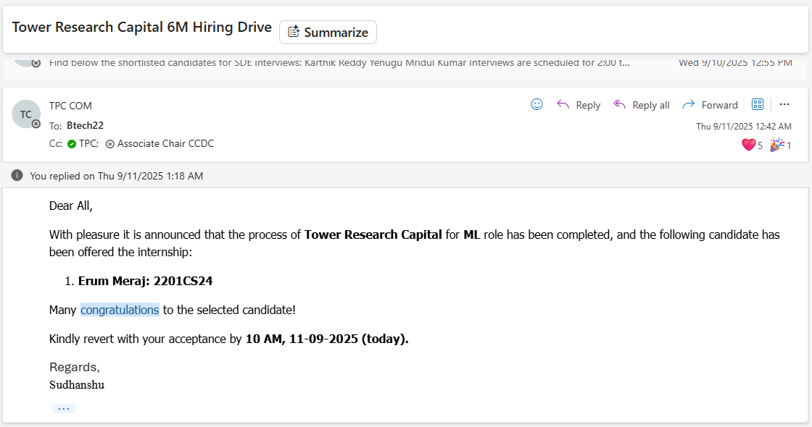

To,
Adean Academic UG
Academic Section

Through Proper Channel:
- Faculty Advisor
- Head of the Computer Science and Engineering Department

Subject: Request for issuance of NOC for 6-month Internship at Tower Research Capital from January 2026 till June 2026

Respected Sir,

I, Erum Meraj (Roll Number: 2201CS24), 4th Year Student of B.Tech in Computer Science and Engineering, am writing to formally request your approval to pursue a 6-month internship at Tower Research Capital (Location: Gurgaon, Mode: In-Person) from January 2026 to June 2026, during my 8th semester, and request the issuance of a No Objection Certificate (NOC) for the same.
As per Office Order Ref No. IITP/Acad/DR/2024/271 (Option 2) dated 18.11.2024, I intend to fulfil my final semester requirements through a hybrid mode, while simultaneously pursuing my internship. I have carefully planned my course registration to ensure all academic obligations are met:
Course Code | Course Name | Credit | Mode
CS457 | Bigdata Security | 6 | IIT Patna
CS548 | Wireless Networks | 6 | IIT Patna
CS563 | Natural Language Processing | 6 | IIT Patna
CS482 | Individual Project (BTP) | 12 | Hybrid
Total Semester Credit: |  |  | 30

I assure you that I will diligently manage my coursework responsibilities through online access to lectures and materials (to be coordinated with the instructors), maintain regular contact with my BTP supervisor, and ensure my presence on campus for all major evaluations including mid-semester and end-semester exams.
To support this request, I have attached:
- Individual permission requests addressed to each course instructor for hybrid learning and access to resources.
- Mail by Centre for Career Development and Counselling regarding offer confirmation.
I sincerely request your kind approval for this internship opportunity and the issuance of the NOC in the attached format. Thank you very much for your support and consideration.

Yours sincerely,
Erum Meraj
Roll No: 2201CS24
B.Tech, Department of Computer Science and Engineering
Indian Institute of Technology Patna
Email: 2201cs24_erum@iitp.ac.in
Phone: 9742192005
Signature

Consent / Instructor Signatures:
Dr. Mayank Agarwal (CS457 and CS548): | ________________________
Dr. Sourav Kumar Dandapat (CS563): | ________________________
Prof. Rajiv Misra (BTP Supervisor): | ________________________
Faculty Advisor | ________________________
Head of the Computer Science and Engineering Department | ________________________

To,
Adean Academic UG
Academic Section

Through Proper Channel:
- Faculty Advisor
- Head of the Computer Science and Engineering Department

Subject: Request for Permission to Complete Wireless Networks (CS548) and Bigdata Security (CS457) in Hybrid Mode

Respected Mayank Agarwal Sir,

I am Erum Meraj (2201CS24), a B.Tech student from the Department of Computer Science and Engineering, and I intend to enrol in CS548 : Wireless Networks (3-0-0-6) and CS457 : Bigdata Security (2-0-2-6) during the 8th semester.
In light of my selection for a six-month internship, I kindly seek your permission to access lab manuals, course presentation slides, and online resources for this course to stay on track with lab work while off-campus.
I plan to visit the campus for mid-semester and end-semester exams to complete all required experiments under your supervision. If you suggest an alternative arrangement, I’m happy to follow it.
I kindly request your approval and signature below to facilitate this arrangement.

Instructor Approval: __________________________ Date: __________________________

Thank you for your time and consideration.
Yours sincerely,
Erum Meraj
Roll No: 2201CS24
B.Tech Computer Science and Engineering
Indian Institute of Technology Patna
Email: 2201cs24_erum@iitp.ac.in
Phone: 9742192005
Signature
To,
Adean Academic UG
Academic Section

Through Proper Channel:
- Faculty Advisor
- Head of the Computer Science and Engineering Department

Subject: Request for Approval to Pursue BTP Alongside Internship

Respected Rajiv Misra Sir,

I am Erum Meraj (2201CS24), enrolled in the Project I (BTP) course for the 8th semester. I am writing to seek your kind approval to pursue my BTP while undertaking a six-month internship at Tower Research Capital from January to June 2026.
As discussed, I will be coming to campus for the mid-semester exams to be available for in-person discussions and project updates. I will remain in regular touch with you throughout to ensure steady progress on the BTP.
I am committed to fulfilling all responsibilities related to the project and sincerely request your support in allowing me to proceed under your guidance.
I kindly request your approval and signature below to facilitate this arrangement.

Instructor Approval: __________________________ Date: __________________________

Thank you for your time and consideration.
Yours sincerely,
Erum Meraj
Roll No: 2201CS24
B.Tech Computer Science and Engineering
Indian Institute of Technology Patna
Email: 2201cs24_erum@iitp.ac.in
Phone: 9742192005
Signature

To,
Adean Academic UG
Academic Section

Through Proper Channel:
- Faculty Advisor
- Head of the Computer Science and Engineering Department

Subject: Request for Permission to Complete Natural Processing Language (CS563) in Hybrid Mode

Respected Sourav Kumar Dandapat Sir,

I am Erum Meraj (2201CS24), a B.Tech student from the Department of Computer Science and Engineering, and I intend to enroll in CS563 : Natural Language Processing (3-0-0-6) during the 8th semester.
In light of my selection for a six-month internship, I kindly seek your permission to access lab manuals, course presentation slides, and online resources for this course to stay on track with lab work while off-campus.
I plan to visit the campus for mid-semester and end-semester exams to complete all required experiments under your supervision. If you suggest an alternative arrangement, I’m happy to follow it.
I kindly request your approval and signature below to facilitate this arrangement.

Instructor Approval: __________________________ Date: __________________________

Thank you for your time and consideration.
Yours sincerely,
Erum Meraj
Roll No: 2201CS24
B.Tech Computer Science and Engineering
Indian Institute of Technology Patna
Email: 2201cs24_erum@iitp.ac.in
Phone: 9742192005
Signature

